INDIAN SPACE RESEARCH ORGANISATION
ISTRAC — LUCKNOW
SUMMER INTERNSHIP PROJECT REPORT

Universal Real-Time Event Ingestion and
Observability Platform
A Prototype for Unified Multi-Source Real-Time Data Monitoring

Submitted by
DHRUV RATHORE
Roll Number: 23052240
B.Tech, Computer Science and Engineering (3rd Year)
KIIT University, Bhubaneswar
Under the Guidance of
Shri Anant Madhukar
Internship Duration: 11th May 2026 – 18th June 2026

CERTIFICATE
This is to certify that the project report entitled “Universal Real-Time Event Ingestion and Observability Platform” is a bona fide record of the Summer Internship work carried out by Dhruv Rathore (Roll Number: 23052240), a 3rd Year B.Tech student of Computer Science and Engineering at KIIT University, Bhubaneswar, during the period 11th May 2026 to 18th June 2026 at ISTRAC, Lucknow, Indian Space Research Organisation.
The work presented in this report represents the genuine effort and original contribution of the candidate towards the design and development of a prototype real-time event ingestion and monitoring platform, carried out under guidance and supervision during the internship tenure.

Guide: Date:
Shri Anant Madhukar _______________

ACKNOWLEDGEMENT
I would like to express my sincere gratitude to Shri Anant Madhukar, my guide at ISTRAC Lucknow, for his continuous support, technical direction, and valuable feedback throughout the duration of this internship. His guidance was instrumental in shaping the scope and direction of this project.
I am grateful to ISTRAC, Indian Space Research Organisation, for providing me with the opportunity to undertake this Summer Internship and for granting access to the technical environment and resources necessary to complete this work.
I would also like to thank KIIT University, Bhubaneswar, for facilitating this internship as part of my academic curriculum and for the foundational technical education that enabled me to undertake a project of this scope.
Finally, I acknowledge the broader engineering and open-source community whose documented patterns and tools — Apache Kafka, OpenSearch, PostgreSQL, and the Node.js ecosystem — formed the technical foundation upon which this prototype was built.

EXECUTIVE SUMMARY
This report documents the design, development, and validation of a Universal Real-Time Event Ingestion and Observability Platform, built as a Summer Internship project at ISTRAC, Lucknow, between 11th May 2026 and 18th June 2026.
Ground station operations generate continuous streams of data from multiple heterogeneous sources — network equipment, application systems, and custom protocols — each potentially using a different data format. The absence of a unified ingestion and monitoring layer makes real-time cross-source visibility difficult to achieve without building source-specific integrations for every new data type.
This project addresses that gap with a deliberately format-agnostic architecture. Rather than building dedicated parsers for each known source type, the system implements a generic, plugin-based pipeline: a Receiver Layer accepts raw data from any source without interpretation, a Parser Engine dynamically detects format and extracts structured fields, a Normalization Layer maps all parsed output into one universal schema, and a real-time delivery layer streams normalized events to a live web dashboard.
The platform was implemented as a microservices-based system comprising six independently running services — an HTTP and Kafka receiver, a parser engine, a normalizer, a WebSocket gateway, an authentication API, and a Next.js dashboard — backed by Apache Kafka for durable message queuing, PostgreSQL for persistent structured storage, OpenSearch for full-text search, Redis for real-time pub/sub delivery, and ClickHouse provisioned for future analytics workloads.
The prototype was validated end-to-end under real operating conditions. Two independent and structurally different data sources — a direct HTTP webhook and an external Apache Kafka topic — were ingested simultaneously, parsed without prior knowledge of their format, normalized into a consistent schema, and rendered live on the dashboard with an observed end-to-end latency of under one second from ingestion to display. The system was also validated for data persistence across full infrastructure restarts and includes a production-pattern authentication layer using JWT tokens with httpOnly cookies, refresh token rotation, and API key support.
This report presents the complete system architecture, design rationale, implementation details, validation results, and a defined roadmap for the next phase of development, including an alert engine, additional format parsers, and formal load testing at production scale.

ABSTRACT
Modern operational environments generate event data from a continuously growing and diversifying set of sources, making fixed, source-specific monitoring integrations increasingly unsustainable. This project presents the design and implementation of a Universal Real-Time Event Ingestion and Observability Platform capable of accepting, parsing, and normalizing data from any source and any format without prior schema knowledge.
The system follows an event-driven, pipeline-based architecture comprising a Receiver Layer, a plugin-based Parser Engine employing dynamic format detection, a Normalization Layer that maps heterogeneous input into a single universal event schema, and a real-time delivery mechanism built on Apache Kafka, Redis Pub/Sub, and WebSocket transport. The system persists data across PostgreSQL, OpenSearch, and Redis, each selected for a distinct architectural role, and exposes a secured REST API protected by JWT-based authentication.
The prototype was validated with simultaneous ingestion from HTTP and Kafka source types, achieving sub-second end-to-end latency from data ingestion to live dashboard rendering. This report documents the complete system design, implementation, validation methodology, and results, along with identified limitations and a roadmap for production-scale extension.
Keywords: real-time data ingestion, event-driven architecture, microservices, Apache Kafka, schema-agnostic parsing, observability, distributed systems

TABLE OF CONTENTS

LIST OF FIGURES
Figure 4.1 — System Architecture Overview
Figure 4.2 — Event Lifecycle and Data Flow
Figure 4.3 — Database Entity-Relationship Diagram
Figure 4.4 — Authentication Flow
Figure 4.5 — Parser Engine Plugin Pipeline

LIST OF TABLES
Table 2.1 — Functional Requirements
Table 2.2 — Non-Functional Requirements
Table 4.1 — Technology Stack Summary
Table 4.2 — Database Schema Summary
Table 6.1 — Validation Test Results
Table 9.1 — Future Enhancement Roadmap

CHAPTER 1: INTRODUCTION

1.1 Organization Overview
The Indian Space Research Organisation (ISRO) operates a network of ground stations under ISTRAC (ISRO Telemetry, Tracking and Command Network) responsible for tracking, telemetry reception, and command transmission for satellites and launch vehicles. The ISTRAC ground station at Lucknow forms part of this network, supporting Telemetry, Tracking, and Command (TTC) operations that require continuous monitoring of data generated by ground equipment and supporting systems.

1.2 Project Background
Ground station operations involve numerous independent subsystems — network equipment, signal processing hardware, application software, and supporting infrastructure — each capable of generating operational data in its own format. As the number and diversity of such systems grows, the practice of building a dedicated, hand-written integration for every individual data source becomes increasingly difficult to sustain. This project was assigned with the objective of exploring and prototyping an alternative approach: a single ingestion platform capable of accepting data from any source, in any format, without requiring prior knowledge of that format.

1.3 Problem Statement
There is no existing unified mechanism to ingest, normalize, and visualize operational event data arriving from heterogeneous and unpredictable sources in real time. Conventional monitoring approaches require a dedicated parser or integration to be developed for each new data source and format, which does not scale as the number of distinct systems generating data increases. The project was undertaken to design and prototype a system that removes this constraint by accepting data generically and determining its structure dynamically at ingestion time.

1.4 Need for the Project
- To reduce the engineering overhead of building a new integration for every new data source
- To provide a single, unified, real-time view across data sources that would otherwise be monitored separately
- To validate whether a format-agnostic ingestion architecture is technically viable under real operating conditions
- To establish a reusable architectural pattern that can be extended to additional source types without redesigning the core system

1.5 Objectives
- Design a real-time ingestion pipeline capable of accepting data from any source and any format
- Implement a dynamic parsing mechanism that detects data format at runtime rather than relying on hardcoded, source-specific logic
- Normalize all incoming data into a single, consistent, queryable schema regardless of its origin
- Provide a live, real-time dashboard for monitoring ingested events as they arrive
- Implement persistent storage so that ingested data survives system restarts
- Implement a production-pattern authentication and access control layer
- Validate the complete system end-to-end under realistic, simultaneous multi-source conditions

1.6 Scope
The scope of this project, as delivered within the six-week internship timeframe, includes the design and implementation of a fully functional prototype covering the ingestion pipeline, parser engine, normalization layer, persistent storage across three database systems, real-time delivery via WebSocket, and a secured web dashboard. Formal production hardening, large-scale load testing, deployment to a Kubernetes cluster, and additional format-specific parsers (CSV, XML, Syslog) are identified as future work and are discussed in Chapter 9.

CHAPTER 2: REQUIREMENT ANALYSIS

2.1 Functional Requirements
Table 2.1 summarizes the functional requirements identified for this system.
ID | Requirement | Description
FR-1 | Multi-source ingestion | Accept data via HTTP and Kafka simultaneously
FR-2 | Format-agnostic parsing | Detect and parse JSON and key-value formats without prior configuration
FR-3 | Event normalization | Map all parsed data into one universal schema
FR-4 | Real-time streaming | Display ingested events on a live dashboard with minimal delay
FR-5 | Persistent storage | Store all events permanently, surviving system restarts
FR-6 | Search and filter | Allow keyword search and severity-based filtering over historical events
FR-7 | Authentication | Restrict dashboard and API access to authenticated users
FR-8 | API key access | Support programmatic access via scoped API keys

2.2 Non-Functional Requirements
ID | Requirement | Target
NFR-1 | Latency | Sub-second delivery from ingestion to dashboard render
NFR-2 | Extensibility | New parsers addable without modifying existing pipeline code
NFR-3 | Scalability | Services must be independently horizontally scalable
NFR-4 | Security | Passwords hashed, tokens stored in httpOnly cookies
NFR-5 | Fault tolerance | No single event loss on transient downstream failure
NFR-6 | Maintainability | Each service independently deployable and testable

2.3 Constraints
- Development and testing conducted on a single development workstation rather than distributed infrastructure
- Six-week internship duration limiting scope to a validated prototype rather than a production deployment
- All infrastructure components containerized via Docker for portability and reproducibility

2.4 Assumptions
- Incoming data, regardless of source, can be reasonably represented as structured or semi-structured text (JSON or key-value pairs) for this phase of the prototype
- A single-tenant deployment is sufficient for prototype validation, though the database schema supports multi-tenancy
- Network connectivity between services is reliable within the prototype's Docker-based environment

CHAPTER 3: SYSTEM ANALYSIS

3.1 Existing System
This project was assigned as a new initiative rather than a replacement or upgrade of an existing system. At the outset, there was no existing platform within the assigned scope of work performing unified, format-agnostic, real-time event ingestion. The project brief was to design and build a working prototype from first principles.

3.2 Gap Analysis
In the absence of a unified ingestion layer, monitoring heterogeneous data sources generally requires one of two approaches, both with significant limitations:
- Building a dedicated integration and parser for every individual source — this does not scale as new sources are introduced and creates ongoing maintenance burden
- Manually inspecting each source's output independently — this prevents any unified, cross-source, real-time view
The identified gap was the absence of a generic, extensible ingestion architecture that separates the concerns of receiving data, detecting its structure, and normalizing it — allowing new sources to be onboarded by adding a small connector rather than redesigning the system.

3.3 Proposed Solution
The proposed solution is a pipeline-based, event-driven architecture structured around four core principles, directly addressing the gap identified above:
- Decouple data reception from data interpretation — receivers accept raw bytes and never parse them
- Detect format dynamically using a plugin-based parser chain, rather than hardcoding parsers per source type
- Normalize all parsed output into one universal schema before it reaches storage or the dashboard
- Stream normalized events to a live dashboard with minimal latency using a Pub/Sub-based real-time delivery mechanism
This architecture is detailed fully in Chapter 4.

CHAPTER 4: SYSTEM DESIGN

4.1 High-Level Architecture
The platform follows an event-driven, pipeline-based architecture in which data flows through eight distinct stages, each implemented as an independently running service. No stage assumes knowledge of what the previous or next stage contains beyond the agreed data contract between them. Figure 4.1 illustrates the complete architecture.
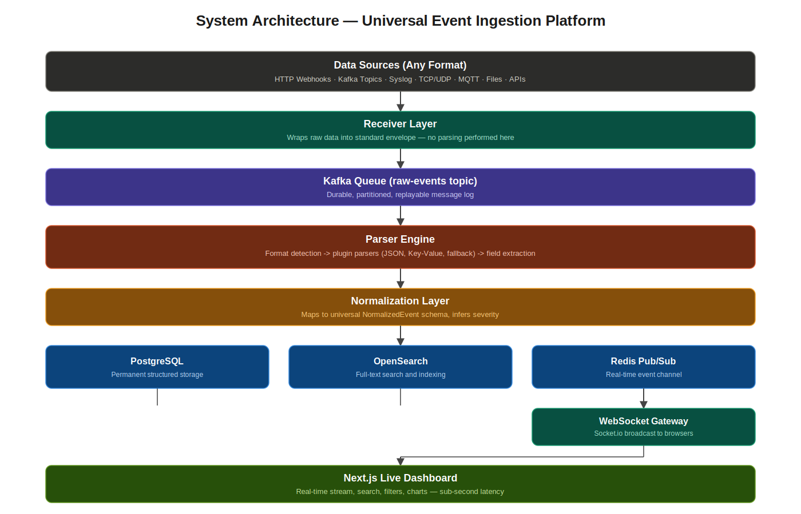
Figure 4.1 — System Architecture Overview

4.2 Component Architecture
Each stage of the pipeline is implemented as a distinct, independently deployable Node.js service:

4.2.1 Receiver Layer
The Receiver Layer is the entry point of the system, responsible solely for accepting raw incoming data and wrapping it into a standard envelope structure. Two receiver implementations were built and validated: an HTTP receiver built on the Fastify framework, exposing a POST /ingest endpoint that accepts any content type, and a Kafka receiver that consumes messages from an external Kafka topic, allowing the platform to ingest from other systems already using Kafka as their messaging backbone. Critically, no parsing or interpretation of the data occurs at this layer — its only responsibility is to record metadata (source type, arrival timestamp, origin) and forward the raw payload downstream.

4.2.2 Queue / Streaming Layer
Apache Kafka serves as the central message backbone connecting every stage of the pipeline. Raw envelopes are published to a raw-events topic; parsed output is published to a parsed-events topic. Kafka's partitioned, durable log structure provides three critical properties for this system: replay capability (any historical raw event can be reprocessed through an updated parser), backpressure handling (if a downstream consumer falls behind, Kafka retains messages rather than dropping them), and consumer group-based horizontal scaling (multiple parser instances can share the workload of a single topic).

4.2.3 Parser Engine
The Parser Engine implements the core format-agnostic capability of the system. Rather than a single monolithic parser, it uses a plugin-based architecture in which each parser exposes two methods: canParse(), which inspects the raw input and returns whether the parser believes it can handle it, and parse(), which performs the actual extraction. The pipeline iterates through registered parsers in priority order and uses the first one that returns true from canParse(). Figure 4.5 illustrates this pipeline.
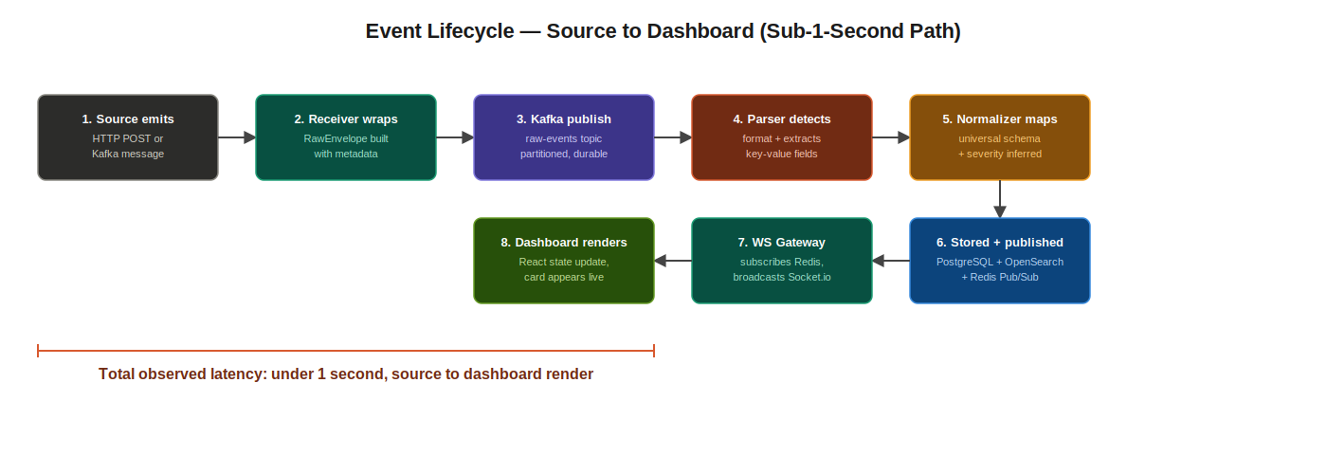
Figure 4.2 — Event Lifecycle and Data Flow (Source to Dashboard)

4.2.4 Normalization Layer
The Normalizer consumes parsed output and maps it into one universal event schema, described fully in Section 4.6. It additionally infers a standardized severity level (critical, error, warn, info, debug, unknown) from common field names used across different source conventions (level, severity, priority), allowing the dashboard to apply consistent visual treatment regardless of how the originating system labeled its severity.

4.2.5 Storage Layer
Three storage systems are used, each selected for a specific architectural role rather than attempting to use one database for every access pattern: PostgreSQL for permanent, structured, queryable storage with full relational integrity; OpenSearch for full-text search across event content; and Redis for low-latency Pub/Sub delivery to the real-time dashboard. ClickHouse is provisioned within the infrastructure for future high-speed analytical aggregation but is not yet integrated into the active write path.

4.2.6 Real-Time Delivery Layer
Real-time delivery to the dashboard uses a two-stage mechanism: the Normalizer publishes every processed event to a Redis Pub/Sub channel, and a dedicated WebSocket Gateway service subscribes to that channel and broadcasts each event to all connected browser clients using Socket.io. This separation allows the WebSocket layer to scale independently of the data processing layer.

4.2.7 Dashboard
The dashboard is built using Next.js 14 with the App Router. It connects to the WebSocket Gateway for live event streaming and to the Authentication API for historical search, filtering, and analytics. Critically, the dashboard renders event fields dynamically using a generic key-value iteration over the event's data object, rather than hardcoding field names — meaning it requires no modification to display data from a newly added source type.

4.3 Network Architecture
All services communicate over a Docker-managed internal network during development, with each service exposing a specific port for external or inter-service access:
Service | Port | Purpose
HTTP Receiver | 4000 | Ingestion endpoint
WebSocket Gateway | 4001 | Real-time event delivery
Authentication API | 4002 | Auth, search, analytics
Dashboard | 3000 | Web frontend
Kafka | 9092 | Message broker
PostgreSQL | 5432 | Relational storage
OpenSearch | 9200 | Search index
Redis | 6379 | Pub/Sub and cache
ClickHouse | 8123 | Analytics (provisioned)

4.4 Data Flow Diagram
Figure 4.2 above illustrates the complete event lifecycle from source to dashboard, including the timing characteristics observed during validation testing, detailed further in Chapter 6.

4.5 Database Design
The persistent data model is implemented in PostgreSQL using ten relational tables, designed with multi-tenancy as a first-class concern even though the current prototype operates with a single default tenant. Figure 4.3 presents the complete entity-relationship diagram.
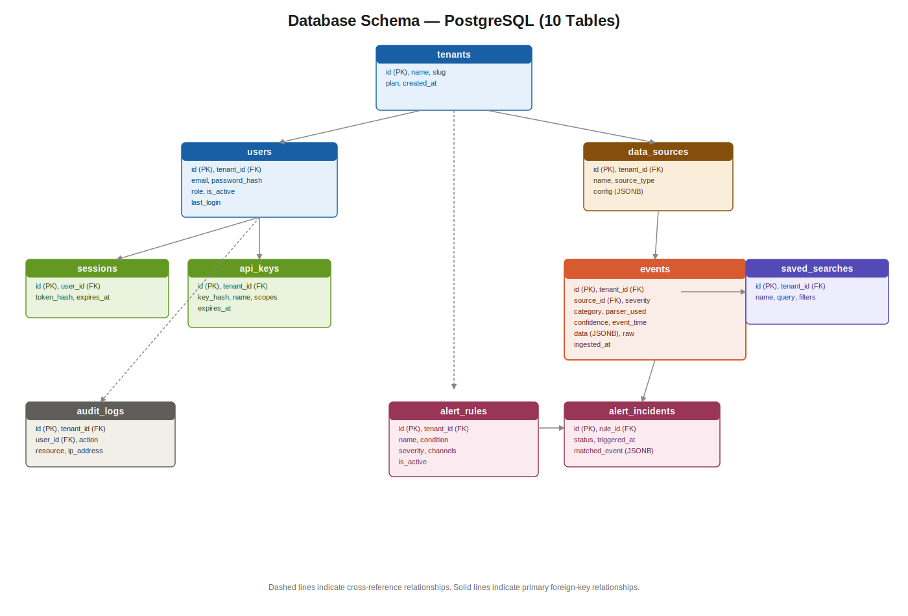
Figure 4.3 — Database Entity-Relationship Diagram

4.5.1 Table Summary
Table | Purpose
tenants | Top-level organizational entity for multi-tenant isolation
users | User accounts with role-based access (admin, viewer)
sessions | Server-tracked refresh tokens enabling revocation
api_keys | Hashed API keys for programmatic access with scoped permissions
data_sources | Registered ingestion endpoints and their configuration
events | Primary event storage with dynamic JSONB field support
alert_rules | Defined conditions for triggering alerts (schema ready, engine pending)
alert_incidents | Record of fired alerts and their resolution status
saved_searches | User-saved search queries and filter configurations
audit_logs | Action-level audit trail for compliance and traceability

4.5.2 Design Rationale
The events table uses a JSONB column (data) to store dynamically extracted fields rather than a fixed set of relational columns. This decision directly supports the format-agnostic requirement: a new data source with an entirely different field structure can be ingested without any database schema migration. Fixed top-level columns (severity, category, event_time) are retained for fields that are universally present across all sources, enabling efficient indexing and filtering, while everything else remains flexible within the JSONB structure.

4.6 Universal Event Schema
Regardless of source or original format, every event is normalized into the following structure before reaching storage or the dashboard:
interface NormalizedEvent {
id: string
timestamp: string
source: { type: string; id: string }
severity: 'critical' | 'error' | 'warn' | 'info' | 'debug' | 'unknown'
category: string
tags: string[]
raw: string
data: Record<string, unknown> // dynamic fields
meta: { parserUsed: string; confidence: number }
}

4.7 Authentication Architecture
Authentication follows a JWT-based pattern with several production-grade refinements. On successful login, the system issues a short-lived access token (15 minutes) and a longer-lived refresh token (7 days), both delivered as httpOnly cookies to prevent access from client-side scripts and mitigate cross-site scripting risk. The refresh token is additionally hashed and stored server-side in the sessions table, allowing individual sessions to be revoked without invalidating all of a user's active tokens. For programmatic and service-to-service access, the system supports API keys, generated as random tokens and stored only as SHA-256 hashes — the raw key is shown to the user exactly once at creation time and is never recoverable thereafter.

CHAPTER 5: IMPLEMENTATION

5.1 Technology Stack
Table 5.1 summarizes the complete technology stack used in the implementation, along with the rationale for each major selection.
Layer | Technology | Rationale
Runtime | Node.js 20, TypeScript | TypeScript enforces interface contracts across six independently deployed services sharing common data schemas
API Framework | Fastify | Higher throughput than Express under equivalent load due to schema-based serialization, important for a high-frequency ingestion endpoint
Message Queue | Apache Kafka | Durable, replayable, partitioned log enabling fault recovery and reprocessing, unlike RabbitMQ's acknowledgement model or Redis Streams' limited retention
Search | OpenSearch 2.11 | Open-source fork of Elasticsearch under Apache 2.0 licensing, suitable for institutional deployment without licensing constraints
Analytics | ClickHouse 23.8 | Columnar storage engine for fast time-series aggregation, provisioned for future integration
Relational DB | PostgreSQL 16 | ACID-compliant relational storage with native JSONB support for dynamic fields
Cache / Pub-Sub | Redis 7 | Sub-5ms in-memory Pub/Sub for real-time dashboard delivery
Real-time Transport | Socket.io | Built-in reconnection handling, room-based broadcast, and graceful degradation
Frontend | Next.js 14 | Hybrid rendering supporting both server-rendered analytics pages and client-side real-time components
Infrastructure | Docker, Docker Compose | Reproducible, portable infrastructure provisioning across development environments

5.2 Development Environment
Development was carried out on a Windows 11 workstation using Visual Studio Code, PowerShell, and Docker Desktop with WSL 2 backend. All infrastructure dependencies — Kafka, Zookeeper, Redis, OpenSearch, PostgreSQL, and ClickHouse — were containerized via Docker Compose, allowing the complete infrastructure stack to be started with a single command and ensuring environment consistency. Application services were run directly via Node.js and ts-node during development for faster iteration and debugging.

5.3 Module-wise Explanation

5.3.1 Receivers Module
Implements two ingestion mechanisms: an HTTP receiver using Fastify exposing POST /ingest, and a Kafka consumer that subscribes to an external topic. Both wrap incoming data into an identical RawEnvelope structure before publishing to the internal raw-events Kafka topic, ensuring the rest of the pipeline is entirely agnostic to which receiver originated the data.

5.3.2 Parser Engine Module
Implements the plugin-based parsing pipeline. Two parsers were built and validated for this prototype phase: a JSON parser achieving 100% confidence on valid JSON input, and a key-value parser using regex-based extraction achieving approximately 70% confidence on key=value formatted text. A fallback parser ensures no event is ever dropped — unparseable input is wrapped as a single message field rather than discarded.

5.3.3 Normalizer Module
Consumes parsed output, applies severity inference logic across common vendor field-naming conventions, constructs the universal NormalizedEvent schema, and performs three parallel write operations: persisting to PostgreSQL, indexing in OpenSearch, and publishing to the Redis Pub/Sub channel for live delivery.

5.3.4 WebSocket Gateway Module
Implements a Socket.io server that subscribes to the Redis events channel and broadcasts incoming events to all connected dashboard clients in real time.

5.3.5 Authentication API Module
Implements login, token refresh, logout, current-user retrieval, API key management, and the search/analytics REST endpoints used by the dashboard. Built using Fastify with the @fastify/jwt and @fastify/cookie plugins.

5.3.6 Dashboard Module
Implements the Next.js frontend, including the live event stream view, historical search interface with severity filtering and pagination, summary statistics cards, and time-series and severity-breakdown charts, all connected to the Authentication API and WebSocket Gateway.

5.4 Source Code Architecture
The project is organized as a monorepo using the following structure, separating applications, independently deployable services, shared packages, and infrastructure configuration:
event-platform/
├── apps/dashboard/ (Next.js frontend)
├── services/
│ ├── receivers/ (HTTP + Kafka ingestion)
│ ├── parser-engine/ (format detection + parsing)
│ ├── normalizer/ (schema mapping + storage writes)
│ ├── ws-gateway/ (Socket.io real-time delivery)
│ └── auth-api/ (authentication + search API)
├── packages/types/ (shared TypeScript interfaces)
└── infra/docker/ (Docker Compose infrastructure)

5.5 APIs and Integrations
The Authentication API exposes the following REST endpoints, all protected by JWT or API key authentication except login:
Method | Endpoint | Purpose
POST | /auth/login | Authenticate and issue tokens
POST | /auth/refresh | Rotate access token using refresh token
POST | /auth/logout | Revoke session and clear cookies
GET | /auth/me | Retrieve current authenticated user
GET | /events | Paginated, filterable event search
GET | /events/stats | Severity breakdown for last 24 hours
GET | /events/timeline | Hourly event counts for last 24 hours
GET | /events/summary | Top-level dashboard summary metrics
POST | /api-keys | Generate new scoped API key

5.6 Configuration Details
All infrastructure services are defined declaratively in a single docker-compose.yml file, allowing the complete stack to be provisioned with one command. Each Node.js service reads its connection configuration (Kafka broker address, PostgreSQL connection string, Redis URL, OpenSearch endpoint) from environment variables, defaulting to localhost-based values during local development and container service names when deployed within the Docker network.

CHAPTER 6: TESTING

6.1 Test Strategy
Given the distributed, multi-service nature of the system, testing focused primarily on functional, end-to-end validation across the complete pipeline rather than isolated unit testing of individual functions. This approach was chosen because the highest-risk failure modes in a system of this kind occur at integration boundaries between services rather than within isolated logic.

6.2 Unit-Level Validation
- Individual parser plugins (JSON, key-value) validated against representative sample inputs to confirm correct field extraction and confidence scoring
- Severity inference logic validated against multiple vendor field-naming conventions (level, severity, priority) and value variants (err, crit, fatal, warning)
- Authentication token generation and verification validated independently of the rest of the pipeline

6.3 Integration Testing
- Full pipeline validated from HTTP ingestion through to dashboard rendering
- Full pipeline validated from external Kafka topic ingestion through to dashboard rendering
- Simultaneous ingestion from both HTTP and Kafka sources validated to confirm no cross-source interference
- PostgreSQL persistence validated to survive complete Docker infrastructure restart
- Authentication flow validated end-to-end: login, protected route access, token refresh, and logout

6.4 Validation Scenarios and Results
Scenario | Expected Result | Outcome
HTTP JSON ingestion | Event parsed, normalized, displayed live | Pass
HTTP key-value ingestion | Event parsed via fallback chain | Pass
External Kafka topic ingestion | Event ingested without HTTP involvement | Pass
Simultaneous multi-source ingestion | Both sources visible on same dashboard concurrently | Pass
Data persistence across restart | Events remain queryable after full restart | Pass
Unauthorized API access | Request rejected with 401 status | Pass
Login and protected route access | Token issued, route accessible with valid token | Pass
Formal load testing at scale | Sustained high-throughput ingestion | Not yet performed

Table 6.1 — Validation Test Results

6.5 Latency Measurement
End-to-end latency was measured informally by observing the elapsed time between issuing an ingestion request and the corresponding event appearing on the live dashboard. Across repeated trials, the observed latency was consistently under one second, despite the event traversing eight distinct processing stages including three separate storage write operations. Formal, instrumented latency measurement under sustained load is identified as future work in Chapter 9.

CHAPTER 7: RESULTS AND DISCUSSION

7.1 Features Delivered
- Fully functional, end-to-end real-time event ingestion pipeline
- Format-agnostic parsing validated across two structurally distinct input formats
- Dual-source ingestion validated with HTTP and Kafka operating simultaneously
- Persistent storage across PostgreSQL and OpenSearch, validated to survive infrastructure restart
- Live, real-time dashboard with sub-second update latency
- Historical search with keyword search, severity filtering, and pagination
- Summary analytics — event counts, severity breakdown, hourly timeline
- Production-pattern authentication with JWT, httpOnly cookies, refresh rotation, and API keys

7.2 Performance Observations
The most significant performance result observed was consistent sub-second latency from ingestion to live dashboard rendering, despite the architectural decision to perform full parsing, normalization, and triple-store persistence (PostgreSQL, OpenSearch, Redis publish) on every single event rather than taking shortcuts for the live-update path. This validates that the chosen architecture does not require sacrificing data durability for real-time responsiveness.

7.3 Benefits Achieved
- Demonstrated that a single ingestion pipeline can absorb structurally different data sources without source-specific code changes
- Established a database schema and service architecture ready for multi-tenant, production-scale extension
- Validated a reusable architectural pattern applicable beyond this specific prototype to any environment with heterogeneous, evolving data sources

CHAPTER 8: CHALLENGES AND LEARNINGS

8.1 Technical Challenges

8.1.1 Module System Incompatibility
Several Node.js dependencies, including uuid version 9 and above, transitioned to ECMAScript Module (ESM) format, which is incompatible with the CommonJS module resolution used throughout the project's TypeScript configuration. This surfaced as a runtime ERR_REQUIRE_ESM error that did not appear during compilation, only at execution. The resolution required identifying the specific dependency version boundary and pinning to the last CommonJS-compatible release (uuid 8.3.2) across all affected services.

8.1.2 Distributed State Corruption in Kafka
During iterative development, stopping and restarting Docker containers without clearing persistent volumes caused Kafka to fail on startup with a KeeperException: NodeExists error originating from Zookeeper. The root cause was a stale broker registration node retained in Zookeeper's persistent volume from a previous container lifecycle, conflicting with the newly starting broker's attempt to register under the same identifier. This was not a code defect but a distributed systems state-management issue, requiring an understanding of how Kafka brokers register themselves in Zookeeper's ephemeral node structure. The resolution required a full volume wipe and clean re-initialization.

8.1.3 Cross-Service Type Sharing in Containerized Builds
The initial design shared TypeScript interfaces via a single packages/types workspace package, referenced through relative imports across services. This worked during local development but failed during Docker image builds, since each service's Docker build context only includes its own directory and cannot resolve paths outside it. The resolution was to duplicate the shared type definitions locally within each service rather than relying on a cross-directory reference, trading minor duplication for build reliability — an explicit and documented trade-off.

8.2 Engineering Decisions
- Chose to duplicate shared types per service rather than introduce a more complex monorepo build tool configuration, prioritizing build reliability within the available timeframe over strict DRY adherence
- Chose to run application services directly via Node.js during development rather than containerizing them, reserving Docker for infrastructure components only, to maximize development iteration speed
- Chose to perform full synchronous writes to all three storage systems on every event rather than introducing write-behind buffering, prioritizing data durability and simplicity over marginal latency reduction, an acceptable trade-off given the sub-second latency still achieved

8.3 Lessons Learned
This project provided practical experience in debugging failure modes specific to distributed systems — particularly the distinction between application-level bugs and infrastructure-level state issues, which require fundamentally different diagnostic approaches. Precisely reading and interpreting error messages and stack traces, rather than retrying or guessing, repeatedly proved to be the difference between resolving an issue in minutes versus hours. The project also reinforced the value of designing clear service boundaries and data contracts upfront: with six independently running services, well-defined interfaces between them were what made the system manageable for a single developer to build, debug, and reason about within a constrained timeframe.

CHAPTER 9: FUTURE ENHANCEMENTS

9.1 Pending Features
Table 9.1 outlines the identified roadmap for the next phase of development, building directly on the foundation established in this prototype.
Enhancement | Description | Readiness
Alert Engine | Rule evaluation and notification delivery (webhook, email) on defined conditions | Schema ready; engine pending
CSV Parser | Plugin parser for comma-separated tabular input | Designed; not implemented
XML Parser | Plugin parser for XML-formatted input | Designed; not implemented
Syslog Receiver | RFC 5424 / 3164 compliant UDP/TCP syslog listener | Designed; not implemented
ClickHouse Integration | Wire normalizer to write analytics data for high-speed aggregation | Infrastructure provisioned
Formal Load Testing | Instrumented throughput and latency testing at production-representative scale | Not started
Kubernetes Deployment | Production-grade orchestration with auto-scaling | Not started

9.2 Scalability Improvements
The architecture was designed with horizontal scalability as a structural property rather than an afterthought. Every service except the WebSocket Gateway is fully stateless, meaning additional replicas can be deployed without coordination. The WebSocket Gateway can itself be made horizontally scalable using Socket.io's Redis adapter for cross-instance room synchronization. Kafka consumer groups allow parser and normalizer replicas to scale independently of one another based on observed consumer lag. These properties are architecturally validated but not yet load-tested at scale, representing the most immediate next validation step.

9.3 Research Opportunities
- Exploring AI-assisted parsing for entirely unknown formats that do not match any existing parser plugin, using a language model to infer field structure and automatically generate a reusable extraction pattern
- Investigating WASM-based sandboxed parser plugins to allow safe, isolated execution of third-party or community-contributed parsers
- Evaluating streaming SQL engines (such as Apache Flink) for continuous, standing queries that trigger on defined conditions rather than periodic polling

9.4 Long-Term Vision
The long-term vision for this work is a fully self-extending ingestion platform where onboarding a new data source requires no source-specific code at all — only a connector pointing at the new source, with the existing parser chain, normalizer, and dashboard requiring zero modification. Within an ISTRAC ground station context, this would mean that as new equipment or systems are introduced, their operational data becomes visible on the unified monitoring dashboard without dedicated integration engineering for each addition.

CHAPTER 10: CONCLUSION
This project successfully designed, implemented, and validated a Universal Real-Time Event Ingestion and Observability Platform capable of accepting data from any source and any format without prior schema knowledge. Over a six-week internship period, a complete, six-service, event-driven pipeline was built — spanning ingestion, dynamic parsing, normalization, persistent multi-database storage, real-time delivery, and a secured live dashboard.
The core technical hypothesis of the project — that a single, generic pipeline could replace the conventional approach of building a dedicated integration per data source — was validated under real, simultaneous, multi-source operating conditions. Two structurally distinct sources, HTTP and Apache Kafka, were ingested concurrently and converged into a single, normalized, real-time view with end-to-end latency consistently under one second.
Beyond the working prototype itself, this project establishes a database schema, service architecture, and parser plugin pattern that are directly extensible for the next phase of work, including an alert engine, additional format parsers, and production-scale deployment. The system delivered is not a conceptual design but a functioning, validated prototype, providing ISTRAC with a concrete technical foundation for future investment in unified, format-agnostic operational monitoring.

APPENDIX A: INSTALLATION GUIDE
Prerequisites: Node.js 20 or later, Docker Desktop with Docker Compose, Git.
- Clone the repository: git clone <repository-url>
- Navigate to infra/docker and run: docker compose up -d
- Wait for all containers to report healthy status: docker compose ps
- Verify PostgreSQL schema initialization: docker exec -it postgres psql -U platform -d platform -c "\dt"
- Install dependencies in each service directory: npm install
- Start each service in a separate terminal using: npx ts-node src/index.ts
- Start the dashboard: npm run dev (within apps/dashboard)

APPENDIX B: DEPLOYMENT GUIDE

B.1 Deployment Philosophy
For deployment beyond local development, each service should be containerized individually using its corresponding Dockerfile, with environment-specific configuration supplied via environment variables rather than hardcoded values. Infrastructure services should be provisioned with persistent volume storage to prevent data loss across container restarts.

B.2 Production Readiness Checklist
- Introduce TLS termination at the ingress layer for all externally exposed endpoints
- Move JWT signing keys and database credentials into a secrets manager rather than environment files
- Enable horizontal pod autoscaling for the parser, normalizer, and WebSocket gateway services based on Kafka consumer lag and active connection count respectively
- Configure Kafka topic retention policies appropriate to compliance and replay requirements
- Provision OpenSearch and PostgreSQL with automated backup schedules and tested restore procedures
- Replace the default seeded administrator credentials before any non-local deployment

B.3 Recommended Deployment Targets
For an institutional deployment, container orchestration via Kubernetes is recommended over standalone Docker Compose, primarily for its native support of rolling updates, health-check-driven self-healing, and declarative scaling policies. Docker Compose remains appropriate for development and small-scale proof-of-concept environments such as the one used throughout this internship.

APPENDIX C: USER MANUAL

C.1 Accessing the Dashboard
Navigate to the dashboard URL and log in using the provisioned credentials. The default administrator account is created automatically during database initialization.

C.2 Sending Events
Events can be ingested by sending an HTTP POST request to the /ingest endpoint with a JSON or key-value formatted body, or by publishing a message to the configured external Kafka topic.

C.3 Searching Historical Events
Use the Search History tab on the dashboard to query past events by keyword or severity, with results paginated for large result sets.

APPENDIX D: CONFIGURATION GUIDE
Each service reads its configuration from environment variables, defaulting to localhost-based values during local development. Table D.1 lists the key configuration variables across all services.
Variable | Purpose
KAFKA_BROKER | Kafka bootstrap server address, e.g. localhost:9092
PG_URL | PostgreSQL connection string including credentials and database name
REDIS_URL | Redis connection string for Pub/Sub and caching
OPENSEARCH_URL | OpenSearch REST endpoint for indexing and search
JWT_SECRET | Signing key for authentication tokens, minimum 32 characters; must be changed from the development default before any production use
MQTT_BROKER | MQTT broker address for the MQTT receiver, e.g. mqtt://localhost:1883

All Docker infrastructure is declared centrally in infra/docker/docker-compose.yml, allowing the complete dependency stack to be provisioned or torn down with a single command, ensuring configuration consistency between development sessions.

APPENDIX E: REFERENCES
[1] Apache Kafka Documentation, https://kafka.apache.org/documentation/
[2] OpenSearch Documentation, https://opensearch.org/docs/
[3] PostgreSQL 16 Documentation, https://www.postgresql.org/docs/16/
[4] Next.js Documentation, https://nextjs.org/docs
[5] Fastify Documentation, https://fastify.dev/docs/
[6] Socket.io Documentation, https://socket.io/docs/
[7] RFC 5424 — The Syslog Protocol, IETF

APPENDIX F: ACRONYMS
Acronym | Expansion
ISRO | Indian Space Research Organisation
ISTRAC | ISRO Telemetry, Tracking and Command Network
TTC | Telemetry, Tracking, and Command
JWT | JSON Web Token
API | Application Programming Interface
REST | Representational State Transfer
JSON | JavaScript Object Notation
JSONB | Binary JSON (PostgreSQL data type)
WASM | WebAssembly
ESM | ECMAScript Module

APPENDIX G: GLOSSARY
- Receiver — A service component responsible solely for accepting raw incoming data and tagging it with metadata, without performing any parsing
- Normalization — The process of converting parsed, heterogeneous data into one consistent schema
- Pub/Sub — A messaging pattern in which publishers send messages to a channel without knowledge of subscribers, and subscribers receive messages without knowledge of publishers
- Consumer Group — A Kafka mechanism allowing multiple consumer instances to share the workload of processing messages from a topic
- Plugin-based Architecture — A design pattern in which functional units (parsers) are registered dynamically and selected at runtime, rather than hardcoded into the calling logic

